**Tutorial No. 08**

**Title: Introduction to React JS.**

# Batch: B2 Roll No.: 16010421119 Tutorial No:8

**Aim**: To implement methods, functions to manipulate DOM element using React JS

# Resources needed: Notepad++, Web Browser Theory:

**React JS**

React is a declarative, efficient, and flexible JavaScript library for building user interfaces.

It lets you compose complex UIs from small and isolated pieces of code called components”. We use components to tell React what we want to see on the screen. When our data changes, React will efficiently update and re-render our components.

React does not manipulate the browser's DOM directly. Instead, React creates a virtual DOM in memory, where it does all the necessary manipulating, before making the changes in the browser DOM.

We will start with React .Component example

class ShoppingList extends React.Component { render() {

return (

<div className="shopping-list">

<h1>Shopping List for {this.props.name}</h1>

<ul>

<li>Instagram</li>

<li>WhatsApp</li>

<li>Oculus</li>

</ul>

</div>

);

}

}

Here, ShoppingList is a React component class, or React component type. A component takes in parameters, called props (short for “properties”), and returns a hierarchy of views to display via the render method.

The render method returns a description of what you want to see on the screen. React takes the description and displays the result. In particular, render returns a React element, which is a lightweight description of what to render.

Most React developers use a special syntax called “JSX” which makes these structures easier to write.

The <div /> syntax is transformed at build time to React.createElement('div').

The example above is equivalent to:

return React.createElement('div', {className: 'shopping-list'}, React.createElement('h1', /* ... h1 children ... */), React.createElement('ul', /* ... ul children ... */)

);

The createElement is an inbuilt method. There are lots of methods and functions included in the reactjs API. see the details on reactjs.org API Reference.

JSX comes with the full power of JavaScript. You can put any JavaScript expressions within braces inside JSX. Each React element is a JavaScript object that you can store in a variable or pass around in your program.

# Hello World Example

<!DOCTYPE html>

<html>

<script src="[https://unpkg.com/react@16/umd/react.production.min.js](https://unpkg.com/react%4016/umd/react.production.min.js)"></script>

<script src="[https://unpkg.com/react-dom@16/umd/react-dom.production.min.js](https://unpkg.com/react-dom%4016/umd/react-dom.production.min.js)"></script>

<script src="[https://unpkg.com/babel-standalone@6.15.0/babel.min.js](https://unpkg.com/babel-standalone%406.15.0/babel.min.js)"></script>

<body>

<div id="mydiv"></div>

<script type="text/babel">

class Hello extends React.Component { render() {

return <h1>Hello World!</h1>

}

}

ReactDOM.render(<Hello />, document.getElementById('mydiv'))

</script>

</body>

</html>

# Setting up a React Environment

First of all you need to download NodeJs for your operating system version. https://nodejs.org/en/download/

npm(node packet manager once you download NodeJs Then follow the following commands:

1. **run the command “**C:\Users\Your Name>npm install -g create-react-app”
2. **run the command to create an application name helloworld “**C:\Users\Your Name>npx create-react-app Helloworld”
3. **run this command to get to the current directory** “C:\Users\Your Name>cd helloworld”
4. **run this command to start the react application** “C:\Users\Your Name\helloworld >npm start”

A new browser window will pop up with your newly created React App! If not, open your browser and type localhost:3000 in the address bar.

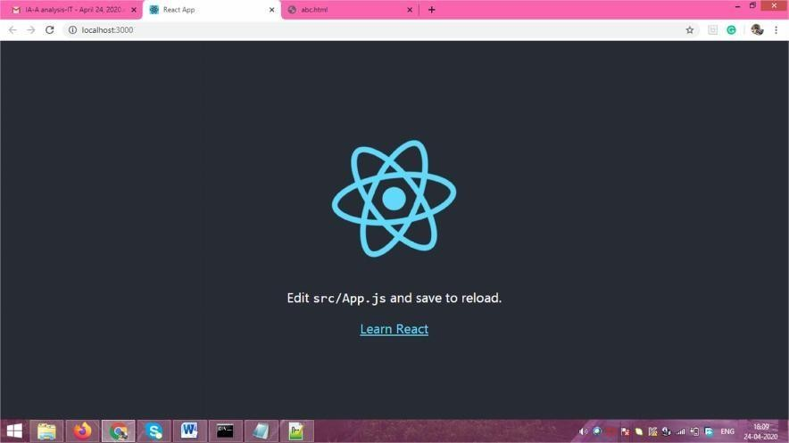

# Modify the React Application

Look in the helloworld directory, and you will find a src folder. Inside the src folder there is a file called App.js, open it and make changes to any HTML part.

You will be able to see the change on the newly opened browser

# App.js File

import React, { Component } from 'react'; import logo from './logo.svg';

import './App.css';

class App extends Component { render() {

return (

<div className="App">

<header className="App-header">

<img src={logo} className="App-logo" alt="logo" />

<p>

Edit <code>src/App.js</code> and save to reload.

</p>

<p> Hi </p>

<a

className="App-link" href="https://reactjs.org"

target="_blank" rel="noopener noreferrer"

>

Learn React

</a>

</header>

</div>

);

}

}

export default App;

in the file “Hi” is added inside paragraph tag. The result browser screen is as follows

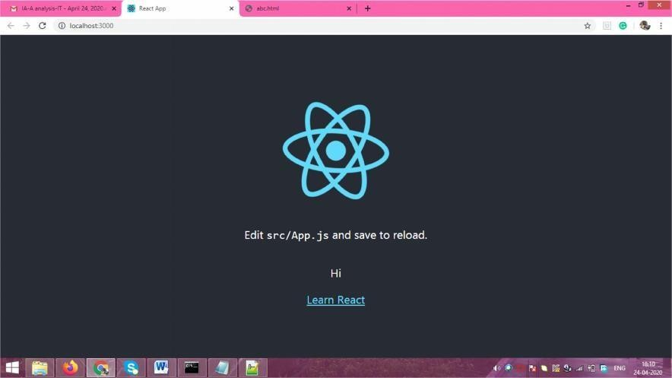

Activity:

* Use React JS to change any of the HTML content.

# Results: (Program printout with output)

# App.jsx:

import React from 'react'

import { BrowserRouter, Routes, Route } from 'react-router-dom'; *// Used for routing in different pages of the webapp*

import './App.css';

import Footer from './components/Footer/Footer';

import Login from './Pages/Login/Login';

import Signup from './Pages/Signup/Signup';

import Profile from './Pages/Profile/Profile';

import Header from './components/Header/Header';

import Home from './Pages/Home/Home';

import Quiz from './Pages/Quiz/Quiz';

import Result from './Pages/Result/Result';

import { useState } from 'react'; *// One of the hooks required in the making of the app*

import axios from 'axios'*//Used for API calling*

function App() {

  const [name, setName] = useState('') *// Name attribute taken from user at the home page*

  const [questions, setQuestions] = useState('') *// This variable will be used during the API Call*

  const [score, setScore] = useState(0) *// The no,. of correct answers the user will give is stored here*

  const fetchQuestions = (category = "", difficulty = "") => {

    axios.get(`https://opentdb.com/api.php?amount=10&category=${category && `&category=${category}`}&difficulty=${difficulty && `&difficulty=${difficulty}`}&type=multiple`, { crossDomain: true })

      .then(response => {

        console.log(response.data);

        const data = response.data;

        setQuestions(data.results);

      })

      .catch(err => {

        console.error(err);

      });

  } *// This section involves the API call from the TRIVIA API using the get function of Axios. JQuery is also involved here*

  return (

*// The main tag for Routing is the BrowserRouter*

    <BrowserRouter>

      <div className="app" style={{ backgroundImage: 'url(./back2.jpg)' }}>

        <Header />

        <Routes>

          <Route path='/' exact element={<Home name={name} setName={setName} fetchQuestions={fetchQuestions} />} />

          <Route path='/quiz' element={<Quiz name={name} questions={questions} score={score} setScore={setScore} />} />

          <Route path='/result' element={<Result score={score} name={name} />} />

          <Route path='/login' element={<Login />} />

          <Route path='/signup' element={<Signup />} />

          <Route path='/profile' element={<Profile />} />

        </Routes>

      </div>

      <Footer />

    </BrowserRouter>

  );

}

export default App;

# Output:

# 

# Outcomes:

# CO4: web application using ReactJS

**Conclusion: (Conclusion to be based on the outcomes achieved)**

We have learnt about React JS and the basics of component architecture.

# Grade: AA / AB / BB / BC / CC / CD /DD

Signature of faculty in-charge with date

# References:

**Books/ Journals/ Websites:**

* [http://www.w3schools.com](http://www.w3schools.com/)
* https:/[/www.tutorialspoint.com/angularjs/angularjs_tutorial.pdf](http://www.tutorialspoint.com/angularjs/angularjs_tutorial.pdf)
* https://angularjs.org